**FRIO COUNTY COMMISSIONERS COURT MINUTES FOR**

**Special Meeting January 31, 2022**

On the 31ST day of January, 2022, at 3:00 p.m., the Commissioners Court of Frio County met in a special meeting with the following members either absent or present, to-wit: Arnulfo C. Luna, Frio County Judge was present; Joe Vela, Commissioner Pct 1 present; Richard “Dicki” Graf, Commissioner Pct 2 present; Raul Carrizales , Commissioner Pct 3 present; Jose Asuncion, Commissioner Pct 4 present; Joseph A. Sindon, Legal Counsel for Frio County Commissioners Court present; and Aaron Ibarra, Frio County Clerk present when the following meeting was held, to-wit:

I. Invocation and Pledge of Allegiance

II. Adopt Agenda

III. Old Business

**PRESENTATION**

**ACTION AGENDA ITEMS**

IV. General Discussion

V. Citizens To Be Heard

**REYNALDO TREVINO**

*Please note that the Rules of Procedure, Conduct and Decorum at Meetings of the Commissioners Court of Frio County, Texas limit each speaker to a maximum of three (3) minutes to make his or her remarks. Inappropriate conduct or comments during this time, including but not limited to disruptive behavior, insults, personal attacks, and inappropriate language, may result in the speaker being ordered to leave the meeting and forfeit any remaining speaking time. For more information regarding the above-mentioned rules, please see the complete Rules of Procedure, Conduct and Decorum at Meetings of the Commissioners Court of Frio County, Texas, which is available upon request.*

VI. New Business

**PRESENTATION**

**ACTION AGENDA ITEMS**

(1) Hon. Raul Carrizales, III. Frio County Commissioner, Precinct No. 3, requests:

Discussion regarding monthly statistics reports compiled by Allegiance.

**NO ACTION**

(2) Hon. Arnulfo C. Luna, Frio County Judge, requests:

Consider /take action on waiving the Fireman’s Park Fees for the BBQ pit area at the request of Mary Jane Barahoma.  Mrs. Barahoma will be hosting a medical benefit Feb. 5th, 2022 11:00 a.m. to 3:00 p.m.

**MOTION: JUDGE LUNA**

**SECOND: RAUL CARRIZALES**

**MOTION PASSED**

(3) Mary Perez, Frio County Human Resources Director, requests:

Consider/take action on designating 5 members to serve on the Frio County Sick Leave Pool Committee. Members are appointed every two (2) years. The current Sick Pool Committee members are Mary Perez H.R. Director, Crystal Marquez County Auditor, Dixie Richards Accounts Payable, Criselda Marquez Executive Assistant, and Ofilia Trevino District Clerk.

**MOTION: RAUL CARRIZALES**

**SECOND: RICHARD GRAF**

**MOTION PASSED**

(4) Hon. Mike Morse, Frio County Sheriff, requests:

Consider/take action on waiving the probationary period for being able to access Blue Cross Blue Shield of Texas Insurance Benefits for new employees Detention Officers Isaac Perez, Steve Sanchez, Diana Garcia, Erik Aguilar, Mark Mendoza, Ella Trevino and Jimmy Allen and Telecommunications Operator Jasmin Garcia.

**MOTION: JUDGE LUNA**

**SECOND: RAUL CARRIZALES**

**MOTION PASSED**

(5) Hon. Mike Morse, Frio County Sheriff, requests:

5.1 Discussion regarding Texas Jail Commission Jail Staff Analysis Report.

5.2 Consider/take action on approving additional jail staff budget as previously presented.

**MOTION: RICHARD GRAF**

**SECOND: RAUL CARRIZALES**

**MOTION PASSED**

(6) Hon. Mike Morse, Frio County Sheriff, requests:

6.1 Consider/take action on approving Sales Contract between Nordicom, Inc. and Frio County for the purchase of SECURalert transmitters for Frio County Detention Officers.

6.2 If the contract is approved, consider/take action on signing resolution authorizing Hon. Arnulfo C. Luna, Frio County Judge, to sign same on behalf of Frio County.

**MOTION: CARRIZALES**

**SECOND: RICHARD GRAFF**

**AGAINST: JOE VELA**

**MOTION PASSED**

(7) Carlos Segura, Frio County Elections Administrator, requests:

Consider/take action on granting permission to seek/apply for further HAVA grant monies following recent notification of said grant extension.  (A final decision will be made by Commissioners’ Court for acceptance of any grant award in view of Frio County’s requirement of matching funds).

**MOTION: RICHARD GRAF**

**SECOND: RAUL CARRIZALES**

**MOTION PASSED**

(8) Carlos Segura, Frio County Elections Administrator, requests:

Approval for cost of 25% of Elections security - updated Election code **mandated** for the March 1, 2022 Primary Election, address posting of security during day of election’s central county station (tabulation center).  Also, the EA requests discussion, consideration, and decision made on security site support (monitoring) for all 9 Day of Election polling sites.

**MOTION: RAUL CARRIZALES**

**SECOND: RICHARD GRAFF**

**MOTION PASSED**

(9) Hon. Crystal Marquez, Frio County Auditor, requests:

9.1 Consider/take action to accept the Modular Project Proposal and Application presented by BOXX, for the purchase of one Budgetary New Custom 50’X64’ Modular Office Building for a total cost of $343,407.00, to be purchased using ARP funding. This is a cooperative purchasing contract under TIPS awarded contact number 200902.

9.2 If the agreement is approved, consider/take action on signing resolution authorizing Hon. Arnulfo C. Luna, Frio County Judge, to sign same on behalf of Frio County.

**MOTION: RICHARD GRAF**

**SECOND: RAUL CARRIZALES**

**MOTION PASSED**

(10) Hon. Crystal Marquez, Frio County Auditor, requests:

Discuss / take action on presenting Security State Bank with a resolution authorizing Frio County Auditor Crystal Marquez to cash Frio County Disbursement checks issued for the Frio County Vaccination Incentive Program in the amount of $5,000.00.

**MOTION: RICHARD GRAF**

**SECOND: RAUL CARRIZALES**

**MOTION PASSED**

(11) Hon. Crystal Marquez, Frio County Auditor, requests:

Consider / take action on approving the amended Frio County Purchasing Card and Procedure Policy.

**MOTION: RAUL CARRIZALES**

**SECOND: JOE VELA**

**MOTION PASSED**

(12) Hon. Crystal Marquez, Frio County Auditor, requests:

12.1 Consider / take action to approve the budget amendments to the FISCAL YEAR 2021-2022 Frio County Budget, list below:

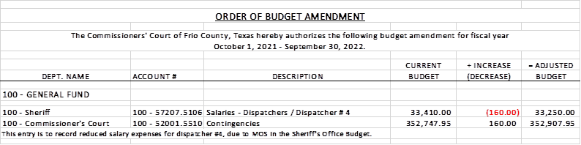

12.2 If the amendment is approved, consider/take action on signing order stating same.

**MOTION: RICHARD GRAF**

**SECOND: RAUL CARRIZALES**

**MOTION PASSED**

(13) Hon. Crystal Marquez, Frio County Auditor, requests:

Consider/take action to certify the revenue received, $1,000.00 under the General Fund (fund 100) and add the following line items to the 2021-2022 Budget to receipt the funds and allow expenses:

Account #: **100-40000.****4368** WALMART COMMUNITY GRANT      Account Name: REVENUES

Account #: **100-58612.5468** WALMART COMMUNITY GRANT      Account Name: SPECIAL PROJECTS

**MOTION: RICHARD GRAF**

**SECOND: RAUL CARRIZALES**

**MOTION PASSED**

(14) Hon. Crystal Marquez, Frio County Auditor, requests:

14.1 Consider / take action to approve the budget amendments to the FISCAL YEAR 2021-2022 Frio County Budget, list below:

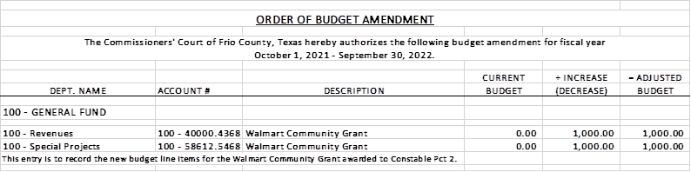

14.2 If the amendment is approved, consider/take action on signing order stating same.

**MOTION: RAUL CARRIZALES**

**SECOND: JOSE ASUNCION**

**MOTION PASSED**

(15) Hon. Crystal Marquez, Frio County Auditor, requests:

15.1 Consider / take action to approve the budget amendments to the FISCAL YEAR 2021-2022 Frio County Budget, list below:

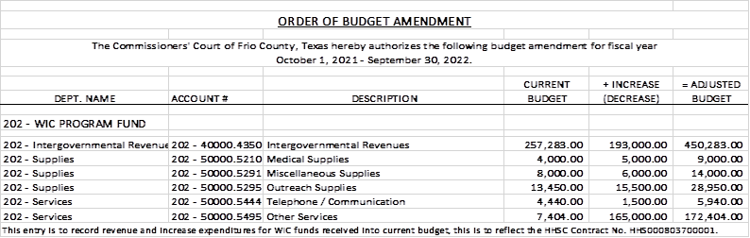

15.2 If the amendment is approved, consider/take action on signing order stating same.

**MOTION: RICHARD GRAF**

**SECOND: RAUL CARRIZALES**

**MOTION PASSED**

(16) Hon. Crystal Marquez, Frio County Auditor, requests:

Consider/take action on the acceptance of donated funds in the amount of $3,586.10 from Brummet Cemetery to Frio County, to be utilized for the purchase of concrete benches for the Brummet Cemetery.

**MOTION: RICHARD GRAF**

**SECOND: RAUL CARRIZALES**

**MOTION PASSED**

(17) Roxana Garcia, P.E., Frio County Engineer, requests:

17.1 Consider/take action on approving the Master Services Agreement for Professional Services between Frio County and SJPA, LLC for design services on an on-call basis and at the request of the County.

17.2 If the agreement is approved, consider/take action on signing resolution authorizing Hon. Arnulfo C. Luna, Frio County Judge, to sign same on behalf of Frio County.

**MOTION: RAUL CARRIZALES**

**SECOND: JOSE ASCUNCION**

**COMMISSIONER VELA ABSTAINED**

**MOTION PASSED**

(18) Roxana Garcia, P.E., Frio County Engineer, requests:

18.1 Consider/take action on approving the Work Authorization No. 1 in the amount of $30,155.49 between Frio County and SJPA, LLC for design services to include construction phase services for the County building located at 1796 I-35BL, Pearsall, Texas 78061.

18.2 If the agreement is approved, consider/take action on signing resolution authorizing Hon. Arnulfo C. Luna, Frio County Judge, to sign same on behalf of Frio County.

**MOTION: RICHARD GRAF**

**SECOND: RAUL CARRIZALES**

**COMMISSIONER VELA ABSTAINED**

**MOTION PASSED**

(19) Roxana Garcia, P.E., Frio County Engineer, requests:

19.1 Consider/take action on approving the Work Authorization No. 2 in the amount of $6,000.00 between Frio County and SJPA, LLC for design services to include value engineering modifications and documents for the County building located at 1796 I-35BL, Pearsall, Texas 78061.

19.2 If the agreement is approved, consider/take action on signing resolution authorizing Hon. Arnulfo C. Luna, Frio County Judge, to sign same on behalf of Frio County.

**MOTION: RICHARD GRAF**

**SECOND: RAUL CARRIZALES**

**COMMISSIONER VELA ABSTAINED**

**MOTION PASSED**

(20) Roxana Garcia, P.E., Frio County Engineer, requests:

Consider/take action on approving the use of ARP Funds in the amount of $36,155.49 to fund the building renovations for the County building located at 1796 I-35BL, Pearsall, Texas 78061.

**MOTION: RICHARD GRAF**

**SECOND: RAUL CARRIZALES**

**COMMISSIONER VELA ABSTAINED**

**MOTION PASSED**

(21) Roxana Garcia, P.E., Frio County Engineer, requests:

Consider/take action on approving a Memorandum of Donation between Frio County and Anderson Columbia, LLC for the donation to Frio County of approximately 1,000 to 1,500 steel posts salvaged from the TxDOT Project located on IH 35 from US 57 to SH 85 to maintain and restore various County Roads and Facilities.

**MOTION: RICHARD GRAF**

**SECOND: JOE VELA**

**MOTION PASSED**

(22) Roxana Garcia, P.E., Frio County Engineer, requests:

22.1 Consider/take action on approving and adopting resolutions granting permits to Abel Rodriguez to lay, construct and maintain one four-inch (4”) sewer tap in the County Road 4600, for a total permit fee of $150.00.

22.2 If the resolution is approved and adopted, then authorize Frio County Judge Arnulfo C. Luna to execute the permit on behalf of Frio County, Texas to Abel Rodriguez.

**MOTION: RAUL CARRIZALES**

**SECOND: JOSE ASUNCION**

**MOTION PASSED**

(23) Roxana Garcia, P.E., Frio County Engineer, requests:

23.1 Consider/take action on approving and adopting resolutions granting permits to Abel Rodriguez to lay, construct and maintain one three-quarter inch (3/4”) waterline in the County Road 4600, for a total permit fee of $150.00.

23.2 If the resolution is approved and adopted, then authorize Frio County Judge Arnulfo C. Luna to execute the permit on behalf of Frio County, Texas to Abel Rodriguez.

**MOTION: RAUL CARRIZALES**

**SECOND: JOSE ASUNCION**

**MOTION PASSED**

(24) Roxana Garcia, P.E., Frio County Engineer, requests:

24.1 Consider/take action on approving and adopting resolutions granting permits to Jennifer Lopez to lay, construct and maintain one four-inch (4”) sewer tap in the County Road 4603, for a total permit fee of $150.00.

24.2 If the resolution is approved and adopted, then authorize Frio County Judge Arnulfo C. Luna to execute the permit on behalf of Frio County, Texas to Jennifer Lopez.

**MOTION: JOSE ASUNCION**

**SECOND: RAUL CARRIZALES**

**MOTION PASSED**

(25) Roxana Garcia, P.E., Frio County Engineer, requests:

25.1 Consider/take action on approving and adopting resolutions granting permits to Jennifer Lopez to lay, construct and maintain one three-quarter inch (3/4”) waterline in the County Road 4603, for a total permit fee of $150.00.

25.2 If the resolution is approved and adopted, then authorize Frio County Judge Arnulfo C. Luna to execute the permit on behalf of Frio County, Texas to Jennifer Lopez.

**MOTION: JOSE ASUNCION**

**SECOND: RAUL CARRIZALES**

**MOTION PASSED**

(26) Roxana Garcia, P.E., Frio County Engineer, requests:

Discussion regarding the occupancy status of the Frio County Cemetery and consider/take action on the sale of plots or commitments to sell plots until the Road and Bridge Department can finalize their mapping efforts.

**MOTION: RAUL CARRIZALES**

**SECOND: RICHARD GRAFF**

**MOTION PASSED**

(27) Hon. Joe Vela, Frio County Commissioner, Precinct No. 1, requests:

Consider/take action on paying to replace or replacing the cement frame around the burial plots of Santiago Siller and her husband were laid to rest in after they were damaged.

(28) Hon. Joe Vela, Frio County Commissioner, Precinct No. 1, requests:

Discussion regarding County Road 4229, aka Siller Road.

**NO ACTION**

(29) Hon. Arnulfo C. Luna, Frio County Judge, requests:

Consider taking action on using $5,000 of American Rescue Plan Funds for the purchase of gift cards and heaters.

**SARAH PICARDO WAS MADE INCHARGE OF THE PROJECT**

**MOTION: RAUL CARRIZALES**

**SECOND: JOE VELA**

**MOTION PASSED**

(30) Hon. Arnulfo C. Luna, Frio County Judge, requests:

Consider/take action on extension of Declaration of Local State of Disaster, dated January 27, 2022, by Frio County Judge, Hon. Arnulfo C. Luna, pursuant to Texas Government Code § 418.108(b).

**FINISH APRIL 26TH 2022**

**MOTION: RAUL CARRIZALES**

**SECOND: RICHARD GRAF**

**AGAINST: JOSE ASUNCION**

**MOTION PASSED**

(31) Documents (resolutions, orders, contracts, etc.) to be signed.

**REVIEWED**

(32) Allow bills payable

**PAID**

(33) Adjourn

**MOTION: RAUL CARRIZALES**

**SECOND: RICHARD GRAFF**

**MOTION PASSED**